NATIONAL UNIVERSITY OF MODERN LANGUAGES
Program fundamental assignment # 03

SUBMITTED BY:
ZULQARNAIN HASSAN

SUBMITTED TO:
SIR AAQIB ADEEL
ROLL No: SP21379
Faculty: Engineering and computer science
Department: Software engineering
Section: BSSE-1-A-afternoon
Q No #01:- what is recursion? Explain with two programming examples.
Recursion:
A function that calls itself is known as a recursive function. And, this technique is known as recursion.
The recursion continues until some condition is met.
The Program below shows how recursion works by calling itself over and over again.
#include <iostream>
using namespace std;
int factorial(int);
int main()
{
int n, result;
cout << "Enter a non-negative number: ";
cin >> n;
result = factorial(n);
cout << "Factorial of " << n << " = " << result;
return 0;
}
int factorial(int n)
{
if (n > 1)
{
return n * factorial(n - 1);
} else
{
return 1;
}
}
Output
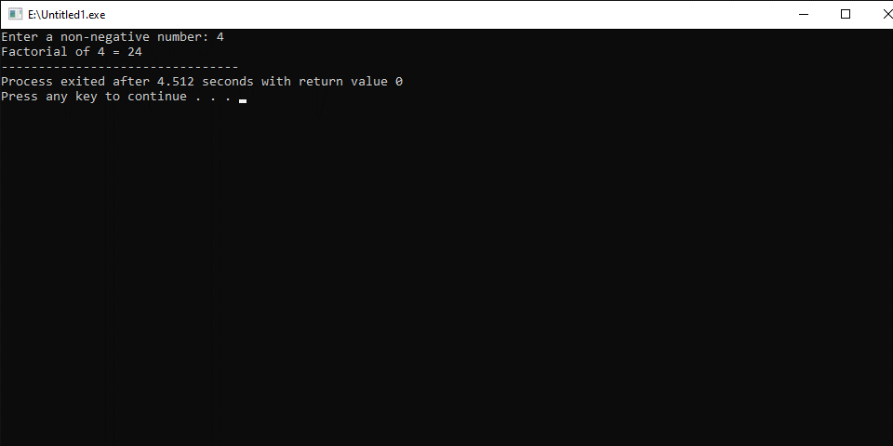
#include <iostream>
using namespace std;
int fibonnaci(int x)
{
if((x==1)||(x==0))
{
return(x);
}
else
{
return(fibonnaci(x-1)+fibonnaci(x-2));
}
}
int main()
{
int x , i=0;
cout << "Enter the number of terms of series : ";
cin >> x;
cout << "\nFibonnaci Series : ";
while(i < x)
{
cout << " " << fibonnaci(i);
i++;
}
return 0;
}
Output

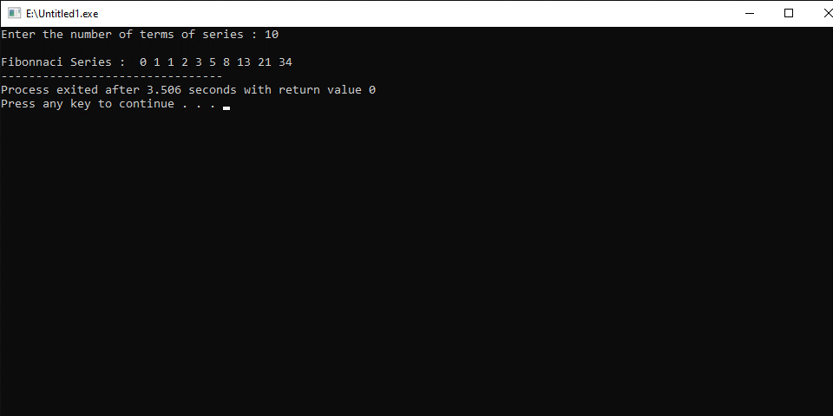
Q No #02:- explain various built-in string operations/functions through coding examples.

Strings
Strings are used for storing text. A string variable contains a collection of characters surrounded by double quotes:
Commonly used built-in string:

strxfrm()
The strxfrm() function in C++ transforms a given null-terminated byte string into an implementation-defined form.

Example
#include <iostream>
#include <cstring>
#include <clocale>
using namespace std;
int main()
{
setlocale(LC_COLLATE, "cs_CZ.UTF-8");
const char* s1 = "hrnec";
const char* s2 = "chrt";
char t1[20], t2[20];
cout << "strcoll returned " << strcoll(s1,s2) << endl;
cout << "Before transformation, " << "strcmp returned " << strcmp(s1,s2) << endl;
strxfrm(t1,s1,10);
strxfrm(t2,s2,10);
cout << "After transformation, " << "strcmp returned " << strcmp(t1,t2) << endl;
}
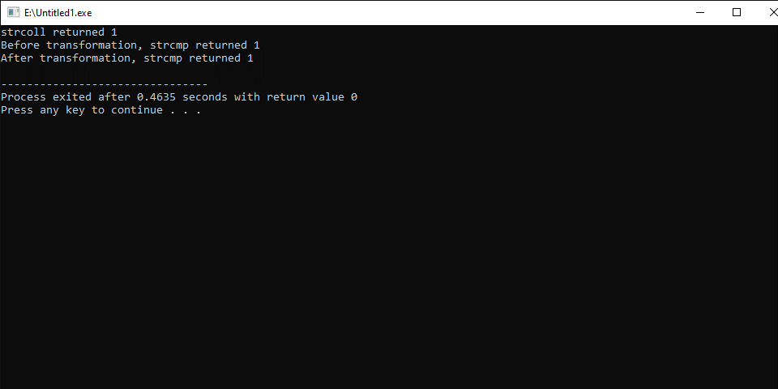

strcoll()
The strcoll() function in C++ compares two null terminating string. The comparison is based on the current locale defined by the LC_COLLATE category.
strcmp() is enough for most string comparisons, but when dealing with unicode characters, sometimes there are certain nuances that make byte-to-byte string comparison incorrect.
#include <cstring>
#include <iostream>
using namespace std;

main()
{
char lhs[] = "Armstrong";
char rhs[] = "Army";
int result;
result = strcoll(lhs,rhs);
cout << "In the current locale ";
if(result > 0)
cout << rhs << " precedes " << lhs << endl;
else if (result < 0)
cout << lhs << " precedes " << rhs << endl;
else
cout << lhs << " and " << rhs << " are same" << endl;

}
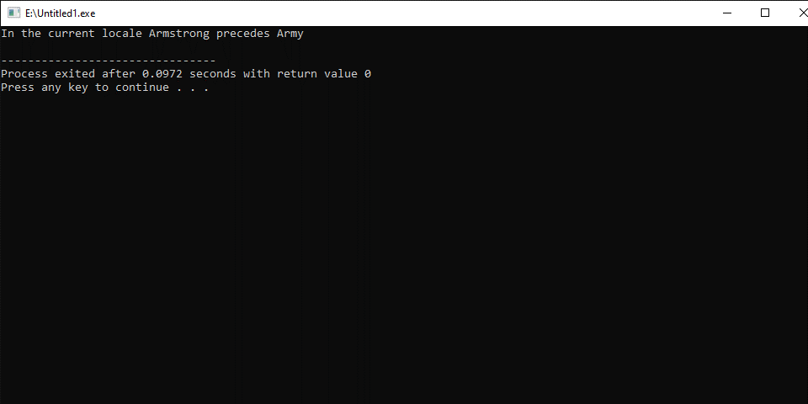

strlen()function:
The strlen() function in C++ returns the length of the given C-string. It is defined in the cstring header file.
#include <iostream>
#include <cstring>
using namespace std;

main() {
char song[] = "We Will Rock You!";

// print the length of the song string
cout << strlen(song);
}
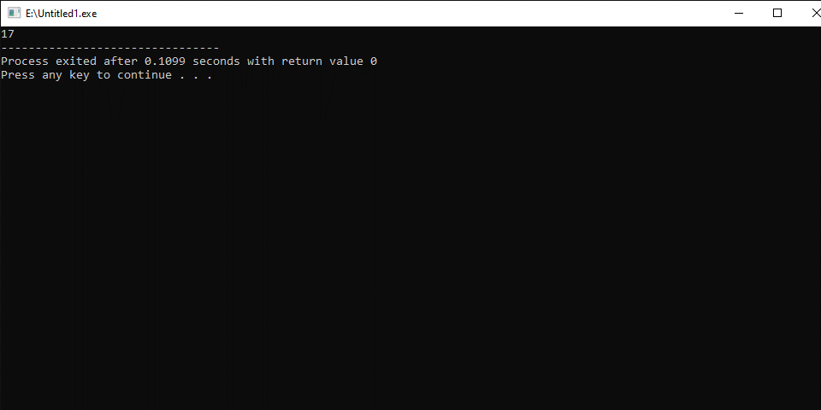

memset()
The memset() function in C++ copies a single character for a specified number of time to an object.
#include <cstring>
#include <iostream>

using namespace std;

int main()
{
char dest[50];
char ch = 'a';
memset(dest, ch, 20);

cout << "After calling memset" << endl;
cout << "dest contains " << dest;
return 0;
}
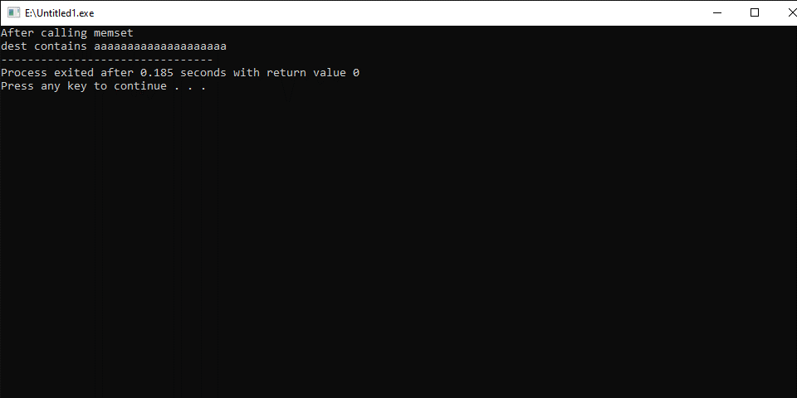

strstr()
The strstr() function in C++ finds the first occurrence of a substring in a string.
#include <cstring>
#include <iostream>

using namespace std;

int main()
{
char str[] = "Use your brain and heart";
char target[] = "brain";
char *p = strstr(str, target);

if (p)
cout << "'" << target << "' is present in \"" << str << "\" at position " << p-str;
else
cout << target << " is not present \"" << str << "\"";

return 0;
}
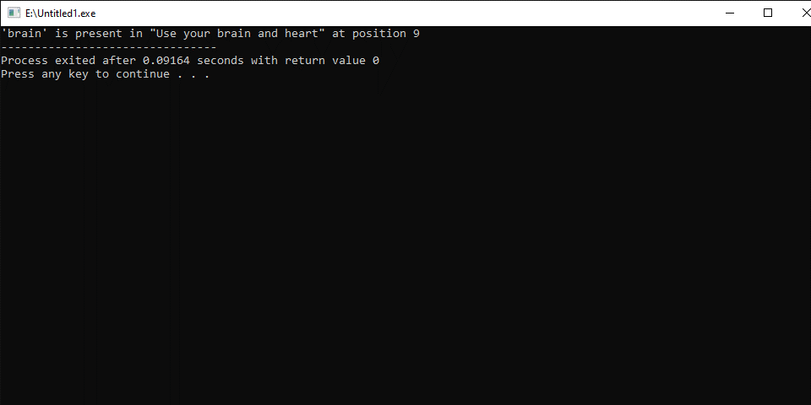

strpbrk()
The strpbrk() function in C++ searches for a set of characters present in a string in another string.
#include <iostream>
#include <cstring>
#include <cstdio>

using namespace std;

main()
{
char digits[] = "0123456789";
char code[] = "ceQasieoLPqa4xz10Iyq";
char *pos;
int count = 0;
pos = strpbrk (code, digits);
while (pos != NULL)
{
pos = strpbrk (pos+1,digits);
count ++;
}

cout << "There are " << count << " numbers in " << code;

}
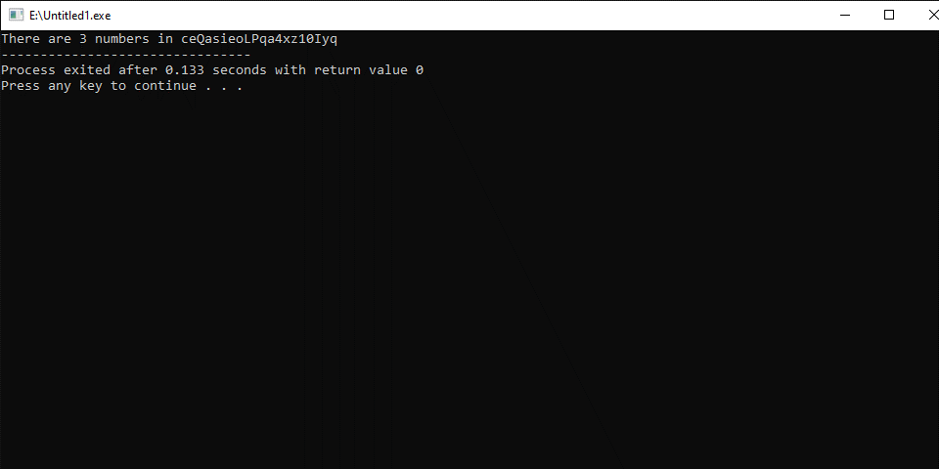

strcmp()function:
The strcmp() function in C++ compares two null-terminating strings (C-strings). The comparison is done lexicographically. It is defined in the cstring header file.
#include <cstring>
#include <iostream>
using namespace std;

int main() {
char str1[] = "Megadeth";
char str2[] = "Metallica";

// compare str1 and str2 lexicographically
int result = strcmp(str1, str2);

cout << result;

return 0;
}
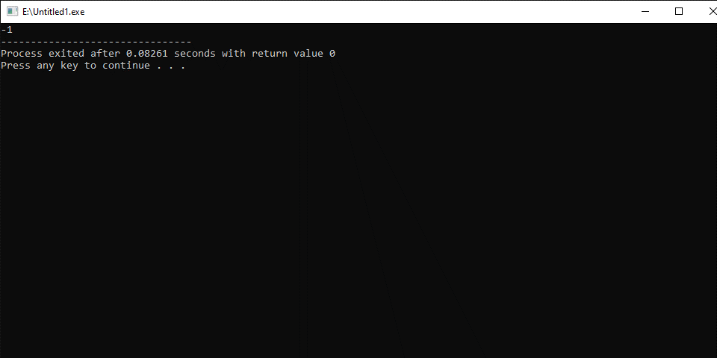
strchr()function:
The strchr() function in C++ searches for the first occurrence of a character in a string.
#include <cstring>
#include <iostream>

using namespace std;

int main()
{
char str[] = "Programming is easy.";
char ch = 'r';

if (strchr(str, ch))
cout << ch << " is present \"" << str << "\"";
else
cout << ch << " is not present \"" << str << "\"";

return 0;
}
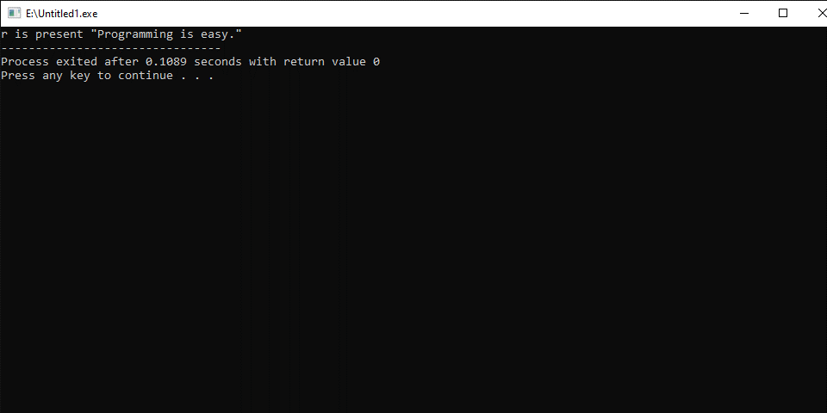
Strcpy()function:
The strcpy() function in C++ copies a character string from source to destination. It is defined in the cstring header file.
#include <cstring>
#include <iostream>

using namespace std;

int main() {
char src[] = "Hello Programmers.";
char dest[20];
strcpy(dest,src);
cout << dest;

return 0;
}
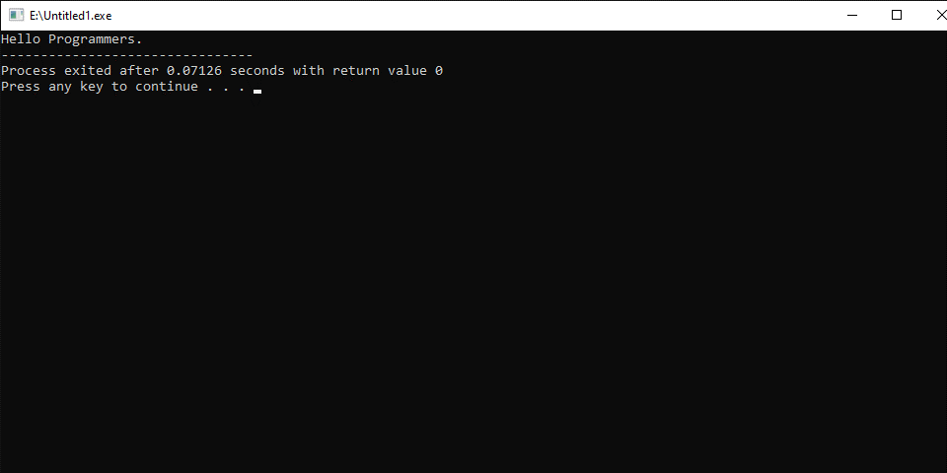

strcat()function:
The strcat() function in C++ appends a copy of a string to the end of another string.
#include <cstring>
#include <iostream>

using namespace std;
int main()
{
char dest[50] = "Learning C++ is fun";
char src[50] = " and easy";

strcat(dest, src);

cout << dest ;

return 0;

}
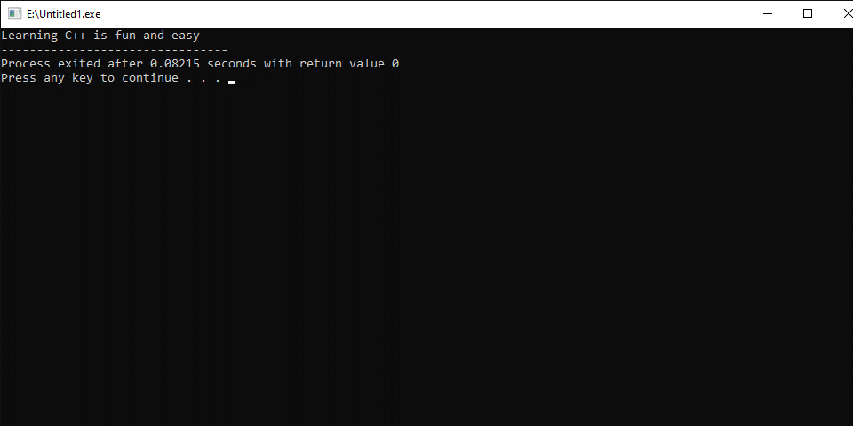

Q No #03:- What is sorting in an array? How does bubble sort work?
Sorting:
Sorting an array means arranging the elements in the array in a certain order. Various algorithms have been designed that sort the array using different methods. Some of these sorts are more useful than others in certain situations.
Here is a step-by-step breakdown of how bubble sorting works:

1. Start with an unsorted list
Bubble sorting starts with an unordered set of items. For example, imagine you are writing a code for an application and need to sort the following data set in ascending order: 4, 3, 1, 2, 5. Since this is a small data set that is mostly ordered already, you can decide to use bubble sort because it is a simple code to implement. After incorporating the code, the bubble sorting algorithm puts the numbers in order by comparing two elements at a time.

2. Compare the first two elements
The algorithm starts by comparing the first two items in the set. If the first item in the set is greater than the second item in the set, it swaps these items. For example, the first number in the data set above is four, which is greater than the second item in the data set, three. The algorithm swaps these numbers and the new data set becomes 3, 4, 1, 2, 5.

3. Assess the second and third elements
Next, the algorithm compares the second item in the list with the third item in the list. If the second item in the list is greater than the third item in the list, the algorithm swaps the numbers. Continuing with the sample data set, the second item in the set is the number four, which is greater than the third item in the set, the number one. The algorithm swaps these numbers and the new data set becomes 3, 1, 4, 2, 5.

4. Continue with the third and fourth elements
The algorithm continues the pattern. Next, it compares the third item in the data set with the fourth item in the data set. In the sample data set, the third number is the number four and the fourth number is two. Since four is greater than two, the algorithm again swaps the numbers. Now, the data set should be 3, 1, 2, 4, 5.

5. Complete the first pass and evaluate the list
Now, the algorithm compares the fourth item in the data set with the fifth item in the set. In the sample list, the fourth item is the number four and the fifth item is the number five. Since the number five is greater than the number four, the algorithm does not swap the items. The set stays 3, 1, 2, 4, 5, and the algorithm completes its first pass. However, since the list is still out of order, the algorithm must complete additional passes. The code automatically prompts the algorithm to continue the pattern until it sorts the entire set.

6. Continue making passes until fully sorted
The algorithm begins its second pass. It follows the same pattern listed in steps 1-5, comparing two items in the set at a time and swapping elements as needed. The algorithm performs as many passes as needed to arrange all items in the set in the correct order. Once it recognizes that the order is correct, it stops without needing additional input. Since the algorithm stops once it has sorted the list, it is easy to know when the list is complete. When the algorithm stops, your set is ready for use.

